INTEGRATION DOCUMENTATION
A. System Overview
The original system is a simple Task Manager made using HTML, CSS, and JavaScript.
Features:
- Add task
- Edit task
- Delete task
- Mark task as completed
Existing limitations/problems:
- No backend
- No data storage
- Data resets after refresh
B. Integration Objectives
The goal is to improve the system by adding a backend API.
Objectives:
- Add server-side data handling
- Connect frontend and backend
- Use REST API
- Improve system structure
C. Integration Plan
Backend Services
- Task API using Node.js and Express
- REST API endpoints for CRUD operations
Service responsibilities
- Backend: handle data
- Frontend: display data
- API: connect both systems
D. Integration Process
- Install Node.js and Express
- Create backend server
- Create API endpoints
- Connect frontend using fetch()
- Test using Postman
- Deploy backend on Render
Technologies used
- Node.js
- Express.js
- REST API
- Render
E. Challenges and Solutions
Problems:
- Connecting frontend to backend
- CORS errors
- Deployment issues
Solutions:
- Used CORS middleware
- Tested using Postman
- Fixed API URL for Render deployment
F. Testing and Validation
Testing tools:
- Postman
- Browser console
- Frontend UI

Tested:
- GET tasks
- POST task
- PUT update task
- DELETE task
- PATCH toggle task
Postman screenshots
- GET tasks
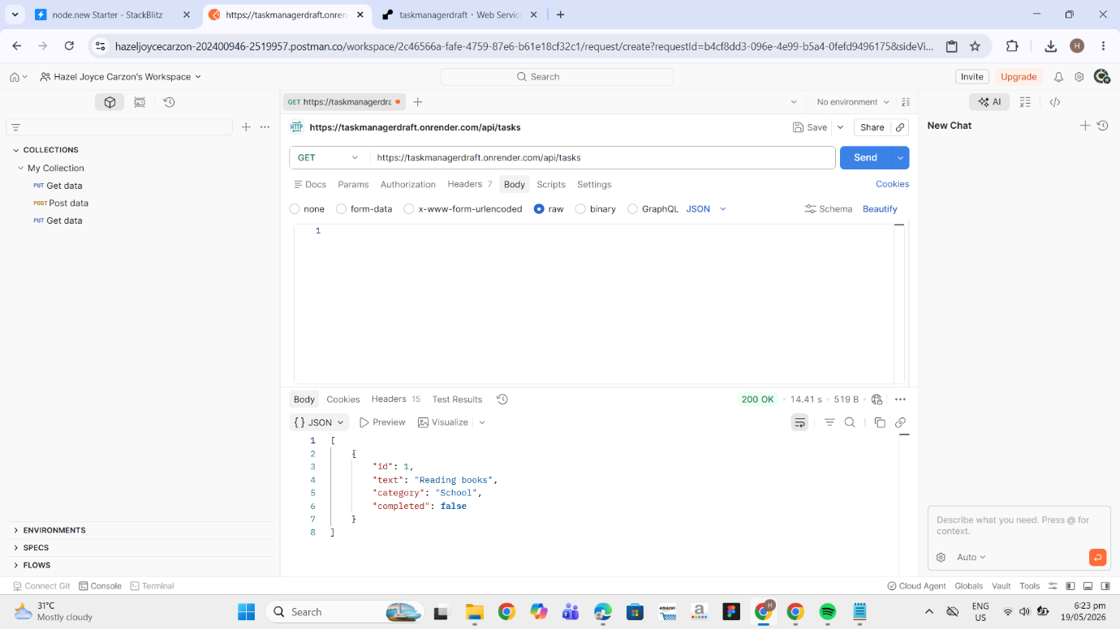

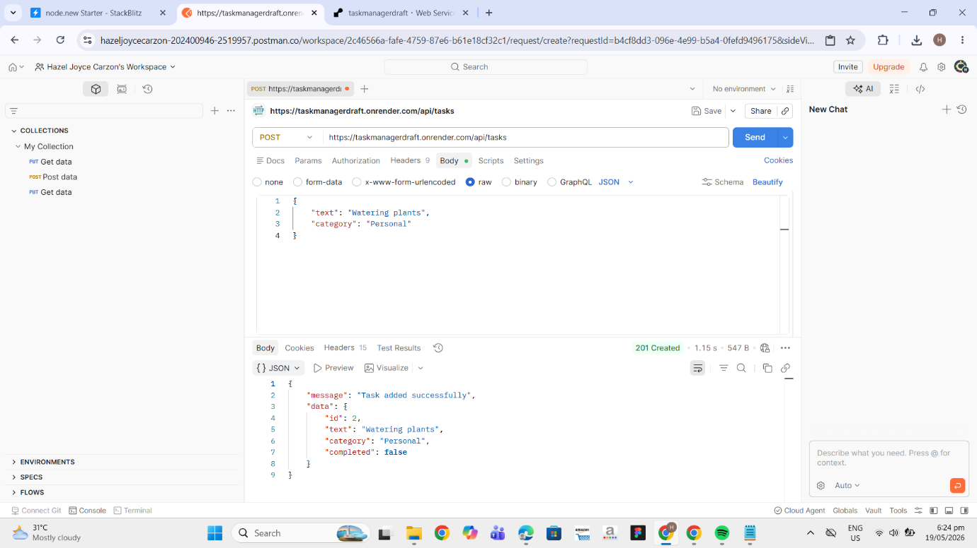
- POST tasks

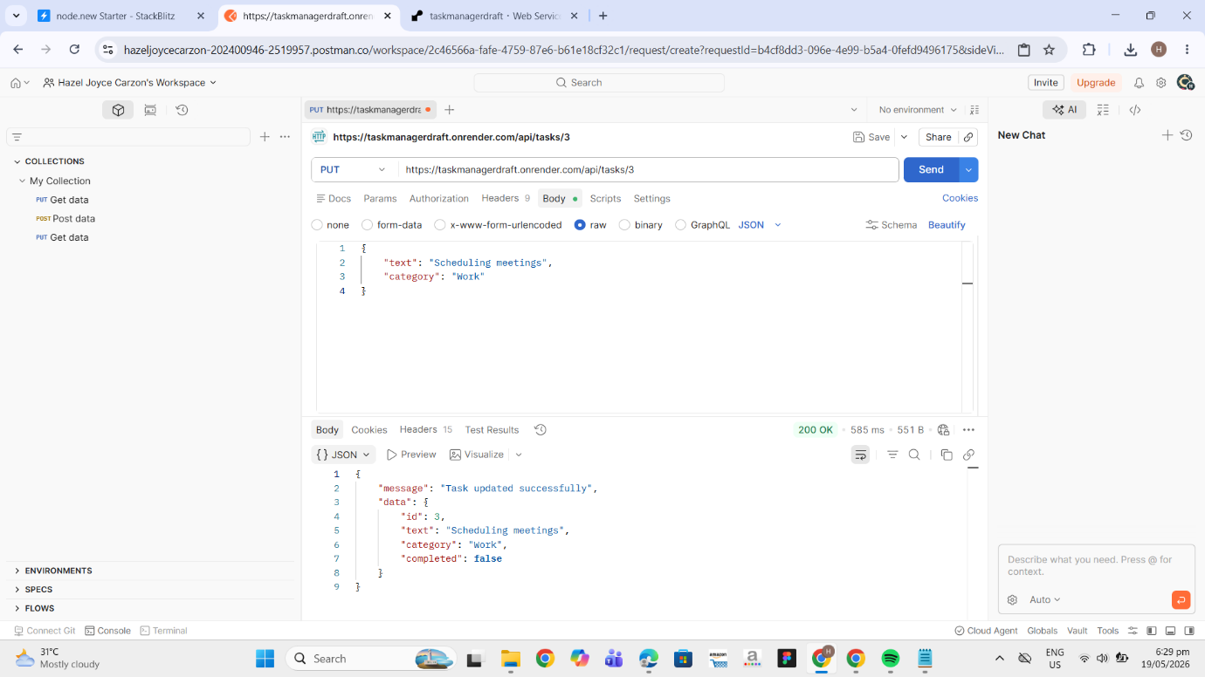
- PUT tasks

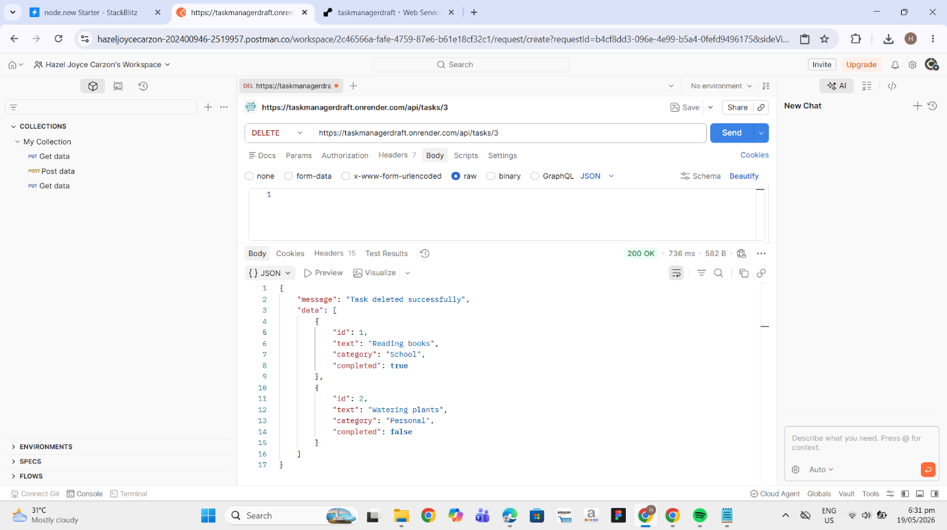
- DELETE tasks

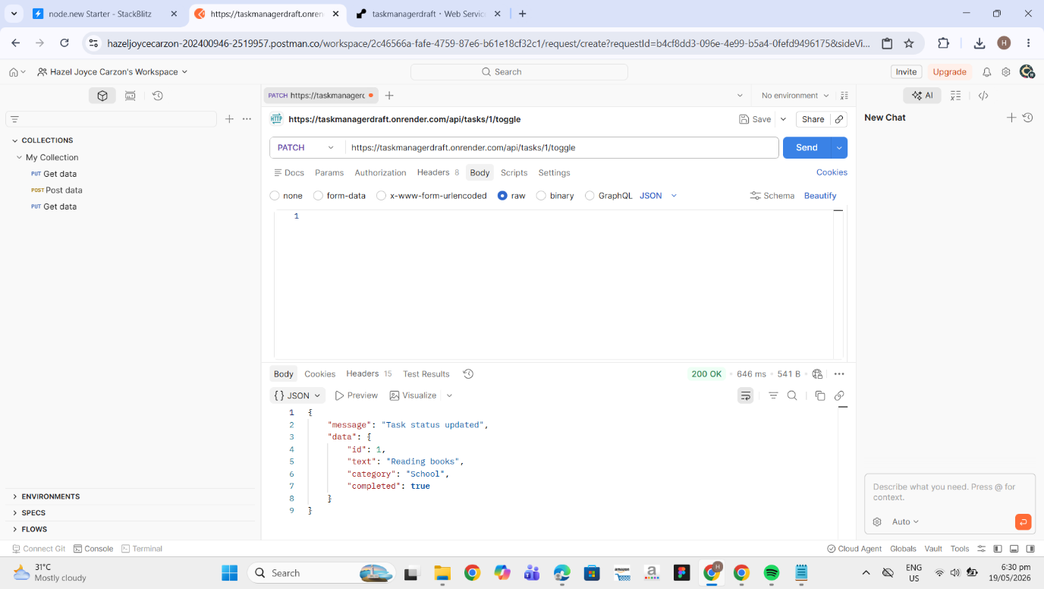
- PATCH tasks

